Dear Friends of my Art,
It still seems like Summer in New England as I write this, but the Fall art season has begun. Here are some places where you can see my work these days:
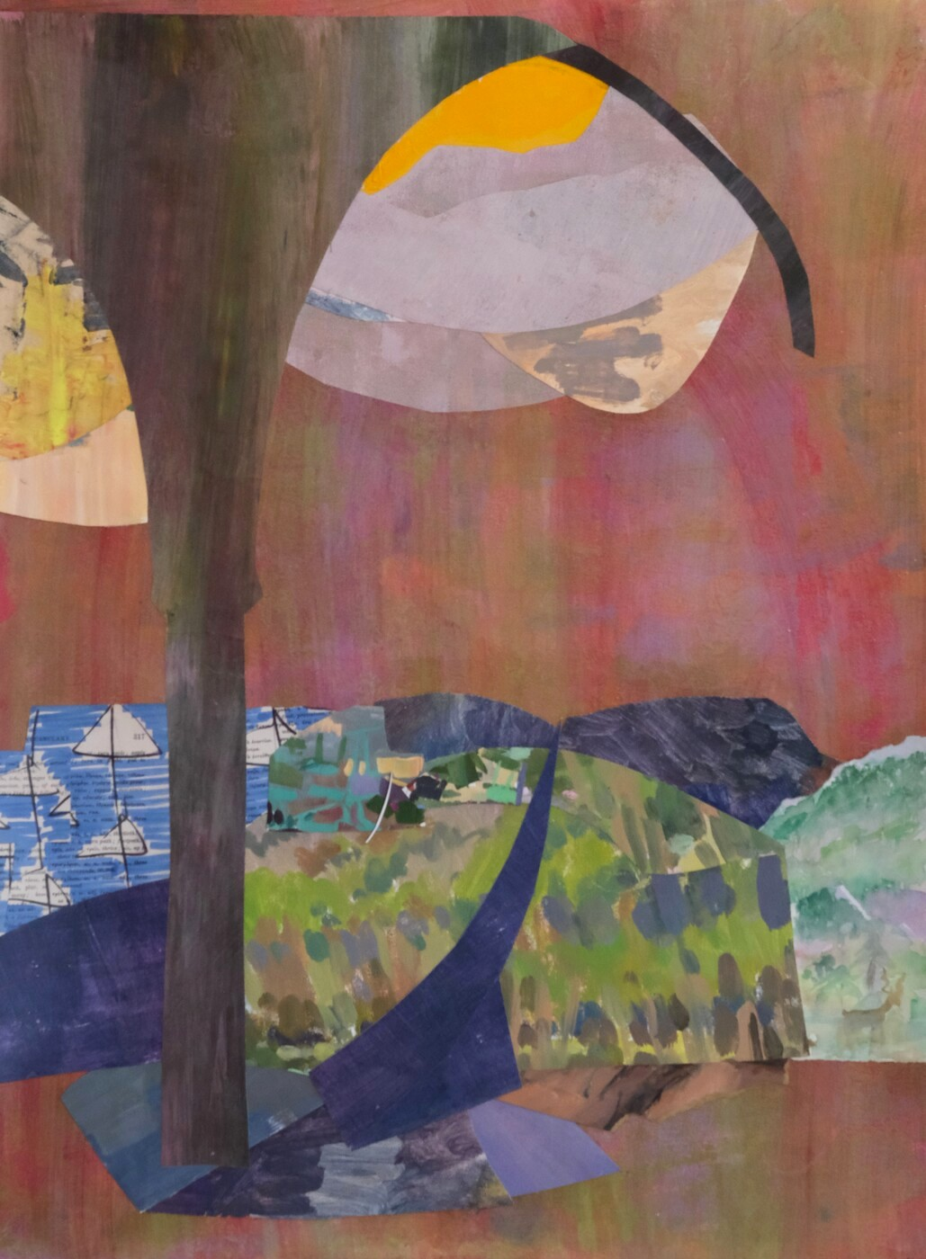
The most comprehensive look is on my website, marawagnerart.com. I have just had an update, so you will find recent work from the summer and a few weeks into the Fall. I was possessed by arch imagery recently, as you will surely see on the site.
On my Instagram site you can also see things I made in Greece in September at a workshop with Nancy Gruskin. @aberdeentreehousestudio
At Cambridge Art Association’s National Prize Show, reception Thursday October 30, 6:00-8:00. My piece, A River Under the Arch, will be at the Schultz Gallery, 25 Lowell St. Cambridge, Ma. The show will be on view October 30 – December 13

At Boston Psychoanalytic Society and Institute, 141 Herrick Rd. Newton, Ma. The show will be up all academic year and includes many wonderful artists.
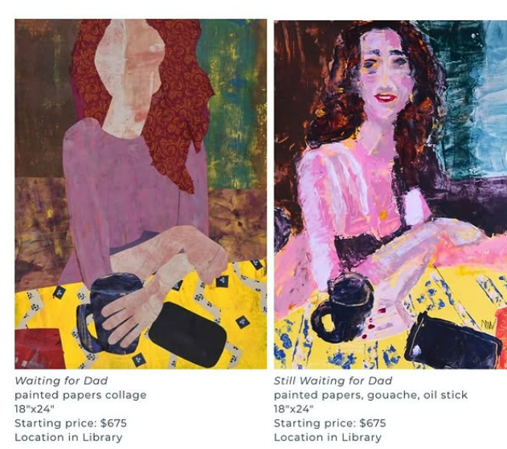

At Gallery1581 (inside Boston Graduate School of Psychoanalysis) 1581 Beacon St. Brookline, Ma. The work is part of the permanent collection.
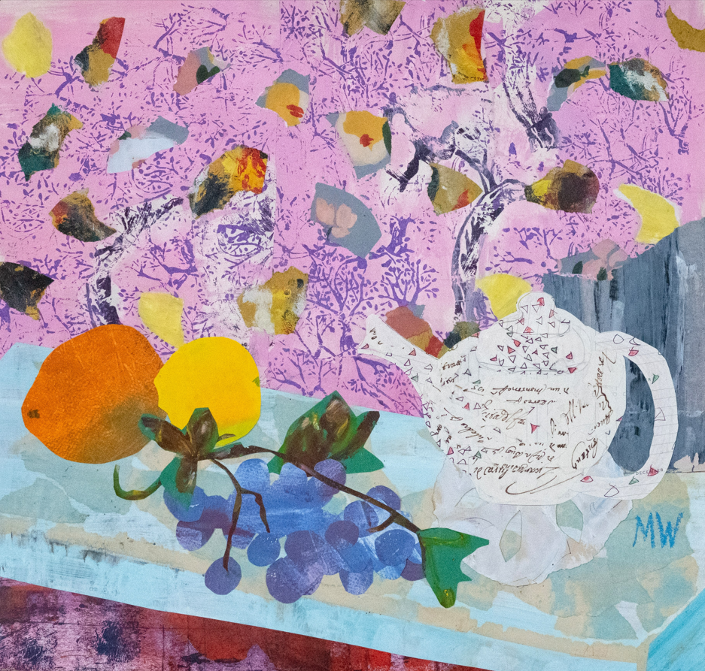

This year I will be part of a three-person Member’s show at Concord Art Association as well! Dates TBD.
And I am happy to say that I will have another guest show at Three Stones Gallery in the coming year, April 29 through June 7! I will send a reminder closer to the date, but the reception will be May 9, Saturday evening.

I will be applying to several other juried shows in the next several weeks, so you will hear from me again shortly, I hope.

Cheers,
Mara

